FORM 2

THE PATENTS ACT, 1970

(39 of 1970)

&

THE PATENTS RULES, 2003

PROVISIONAL SPECIFICATION

[See section 10, Rule 13]

De-centralised Real-time On-road Smart Contracts Based System

MALLIKARJUN SHASHANK, an Indian citizen, of address No.1661, 6th cross MCECHS layout, Shivaram Karanth Nagar 2nd Phase, Bangalore, Karnataka- 560064

THE FOLLOWING SPECIFICATION DESCRIBES THE INVENTION.

1

Technical Field:
The present application relates generally to the field of transactions on distributed ledger platforms and particularly to use of smart contracts for the execution of the transactions. Moreover, an embodiment of the present invention pertains to a negotiation system between vehicles moving in a given area for effective streamlined traffic management. The technology used in this invention is majorly blockchain, interconnected with smart contracts. This technology can be used by individuals, traffic authorities as well as government institutions to regulate and govern traffic. The individual communication module helps to regulate a larger set of people with multiple advanced systems rather than a set of traffic lights governing the entire fleet of vehicles.

Background:
In the past couple of years, there has been a consistent increase in the number of vehicles on the road. There is a dearth in terms of management and communication within the vehicles moving along the same area. This often times causes long hours of getting stuck in the traffic and eventual delay in day-to-day activities. It is almost impossible to interact and reason with the vehicles around so that a way is given for movement of vehicles behind them. In terms of technological advancement, there has not been much done except of standalone systems for effective queue management and traffic control. There is a heightened need for a system that encourages communication on an individual basis in order to streamline traffic in a given area.
The current available systems do not provide adequate clarifications with respect to effective traffic management using advanced technology like smart contracts. This invention aims to use blockchain and smart contracts and facilitate management of traffic with the help of proper vehicle to vehicle communication.
Further, this invention encourages incentive based negotiation to the vehicles which will allow them to interact and negotiate with each other. This will help in a steady flow of information to vehicles in a given area.

Detailed Description:
The following description of the presently contemplated best mode of practicing the invention is not to be taken in a limiting sense, but is made merely for the purpose of describing the general principles of the invention. Embodiments of the present disclosure present technological improvements as solutions to one or more of the above-mentioned technical problems recognized by the inventor in conventional systems. The subject disclosure describes, among other things, illustrative embodiments for a de-centralised real-time on-road smart contracts based system and method, wherein two or more parties can transact with each other in real-time is disclosed. Other embodiments are described in the subject disclosure.
The system and method for transaction between vehicles encompasses various models on which this system functions on. The system will include various other computer – aided interaction systems that will facilitate a vehicle to vehicle communication. This communication will be accompanied with tracking of one or more metrics such as location and lane tracking of the parties for real time updates during such communication.
The core of the entire system are the smart contracts of the block chain. Smart contracts are self-executing agreements between parties that have all the terms & conditions written in code, and execute automatically, depending on future signatures or trigger events. By leveraging block chain technologies, smart contracts, once appended to the block chain, cannot be revoked, denied, or reversed. A smart contract usually provides multiple functions which can be executed by simply invoking a call method on the block chain to which the said smart contract is appended to. As more and more block chains with varied processing and execution speed continue to emerge, multiple smart contracts with various functionalities are being written.
Each transaction between the parties are guided by one or more smart contracts. In the exemplary embodiment of the present invention, a first party is a first user in the system and the second party is a second user, separate from the first user in the system. In an alternate embodiment of the present invention, the second party is a central server.
A transaction between the first party and the second party comprises at least a transaction offer, a transaction acceptance and a transaction result. All these are incorporated in smart contracts.
The transaction offer consists a transaction initiation request, a time of expiry of the transaction offer and one or more transaction terms provided by the first party, wherein the one or more transaction terms comprises a transaction charge, a transaction end result. The second party if it wants to accept the offer, send the transaction acceptance. Upon successful payment of the transaction charge and completion of the transaction end result, the transaction is said to be complete.
If the second party does not want to accept the transaction offer at the one or more transaction terms, the second party sends a negotiation request, to negotiate one or more terms of the transaction. Further, if the second party does not want to transact with the first party, it sends a rejection request.
Another very important aspect of this system is incentives. According to today’s rules and standards a driver is usually always only fined for his negative behaviour. This system aims to appreciate a driver for his positive behaviour while driving, through incentives. These incentives can be monetary or non-monetary. The idea behind this to ensure that when in any particular driver cooperates to clear a lane to help another vehicle pass, there is a certain form of incentive involved in that transaction.
The system will have a ledger (or database) which will keep track of all negotiations that happen between vehicles. It is also equally important to have a database of legal and traffic rules of each geographic area under this system to ensure that the drivers have standard information of rules.
In another exemplary embodiment of the present invention, the system is compatible with autonomous vehicles. In this embodiment, the users in the system are one or more autonomous vehicles. The one or more autonomous vehicles are compatible to perform the transaction based on the pre-defined rules.
For illustration purposes, in an exemplary embodiment of the present invention, the first party is a car, travelling in a particular direction. The driver is in a hurry and is willing to pay a small amount to the vehicles in front of him so that they allow him to overtake them (in return for the incentive). The second party is a truck that is in front of him, in the same lane. The car sends a transaction offer to the truck, with the offer of 5 crypto currencies if the truck allows the car to overtake. The second party, i.e. the truck accepts the offer. Upon successful payment of the 5 crypto currencies, the truck allows the car to overtake and thus the transaction result is achieved.
In an alternate embodiment, the first party is an Ambulance and it is in a hurry, carrying a patient to a hospital. In this case, the second party is the central police traffic server. The ambulance sends a request to the central server, providing the transaction request. The central server accepts the offer and programs the traffic signals in the way of the ambulance in such a manner that the road is clear, after payment of the transaction charges by the ambulance.
It shall be appreciated by the person skilled in the art that the foregoing description and embodiments depict interoperability between two block chain and that the same can be extended to a plurality of block chains communicably coupled to the server arrangement. It will be further appreciated that the terms “first”, “second” and the like herein do not denote any specific role or order or importance, but rather are used to distinguish one party from another.
Any examples or illustrations given herein are not to be regarded in any way as restrictions on, limits to, or express definitions of, any term or terms with which they are utilized. Instead, these examples or illustrations are to be regarded as illustrative only. Those of ordinary skill in the art will appreciate that any term or terms with which these examples or illustrations are utilized will encompass other embodiments which may or may not be given therewith or elsewhere in the specification and all such embodiments are intended to be included within the scope of that term or terms. Moreover, the words “example” or “exemplary” are used herein to mean serving as an example, instance, or illustration. Any aspect or design described herein as “exemplary” is not necessarily to be construed as preferred or advantageous over other aspects or designs. Rather, use of the words “example” or “exemplary” is intended to present concepts in a concrete fashion.
The description, embodiments and figures are not to be taken as limiting the scope of the claims. It should also be understood that throughout this disclosure, unless logically required to be otherwise, where a process or method is shown or described, the steps of the method may be performed in any order, repetitively, iteratively or simultaneously. At least portions of the functionalities or processes described herein can be implemented in suitable computer-executable instructions.
It will be appreciated that features of the present disclosure are susceptible to being combined in various combinations and additional features may be introduced without departing from the scope of the present disclosure.

Diagrams

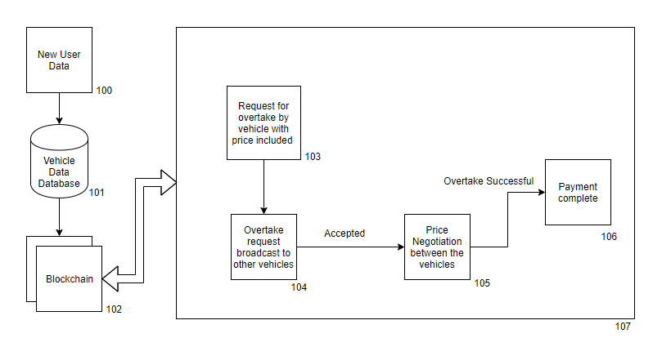

Figure 1: System for communication and negotiation between vehicles

Diagram Description
Fig. 1 describes the system for communication and negotiation between vehicles. In this Fig. the information of a new user (100) gets stored in the Vehicle Data Database (101) which in turn gets transferred to the Blockchain where it is stored. The first step in this transaction process happens when the first party sends an overtake request to the second party; this is done with a transaction charge, a time of expiry of the transaction offer and the end result of the transaction (103). Once this transaction request is made, it is then broadcasted to the other vehicles that are present in that given geographical area (104). The second party can either accept or reject the request. Once the request is accepted, the second party can then negotiate the transaction charge with the first party (105). When the negotiation between both the vehicles is complete, a payment is made by the first party to the second party, upon completion of the payment; the first party can successfully overtake the second party. This completes the transaction between both the parties.

Abstract:
A de-centralised real-time on-road smart contracts based system and method, wherein two or more parties can transact with each other in real-time is disclosed. This system and method uses various communication modules for real-time communication between different modes of transport in a given geographical area for better queue management and traffic control in exchange for some incentive. This invention uses a digital ledger platform to assist and enhance vehicle to vehicle transactions, to ultimately using smart contracts. The transactions such as interactions and negotiation between two or more parties are done through a coordinated computer program that is built on communication modules including blockchain and smart contracts. The use of this system will help with a clear and transparent way of vehicle to vehicle communication and negotiation.

Date:
Signature:

